MRI Task #1

Abdulla Ahmed Ali Zahran Sec: 2 Bench: 5

Samar Ibrahim Sec: 1 Bench: 40

Shymaa Gamal Sec: 2 Bench: 1

Sondos Mohamed Sec: 1 Bench: 42

Contents

Bloch Equations 1

Image Components 4

# Bloch Equations

This is a representation for Bloch Equation in 3-D space using Python IDE

We have generated the following images below:

* M vector with angular frequency 30deg
* Excitation Mode with angular frequency 30deg
* Relaxation Mode with angular frequency 30deg
* Excitation - Relaxation Mode
* Excitation - Relaxation Trajectory on X-Y plane
* Relaxation - Excitation Mode
* Relaxation - Excitation Trajectory on X-Y plane

Main Equations for M vector:

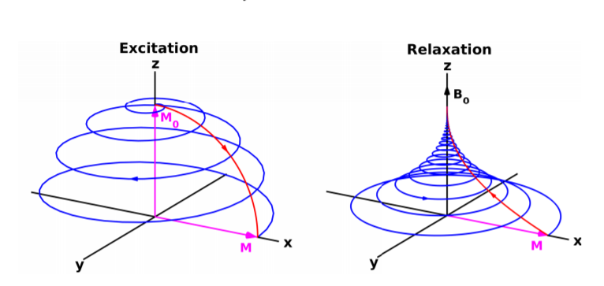where t represents the angle of rotation, z is the angular frequency, by changing z value with respect to t time we have the following representations:

Excitation Model

Relaxation Model

Also, you can set numberOfLoops = 1 to generate single mode [Excitation or Relaxation] only or = 2 to generate dual modes.

## Python Code:

import numpy as np

import imageio

from qutip import Bloch

def animate_bloch(vectors, duration=0.1, save_all=False):

    numberOfLoops = 1

    if numberOfLoops == 1:

        maxAngle = 2*np.pi

    elif numberOfLoops == 2:

        maxAngle = 4*np.pi

    mode = 1

    omega = np.pi/6

    z = 0

    sqAngle = np.pi/2

    a = 5

    vectorM = Bloch()

    images=[]

    for t in np.arange(omega, maxAngle, 0.1):

        if mode == 0:

            z = np.pi/2 * np.sin(t/(4))

            if t == 2*np.pi:

                mode = 1

        elif mode == 1:

            z = np.pi/2 * np.cos(t/(4))

            if t == 2*np.pi:

                mode = 0

        else:

            pass

        vectorM.clear()

        vectorM.add_vectors([np.sin(omega)*np.cos(t), np.sin(omega)*np.sin(t), np.cos(omega)])

        vectorM.add_vectors([np.sin(z)*np.cos(a*t), np.sin(z)*np.sin(a*t), np.cos(z)])

        vectorM.add_vectors([np.sin(sqAngle)*np.cos(t), np.sin(sqAngle)*np.sin(t), np.cos(sqAngle)])

        filename = 'temp_file.png'

        vectorM.save(filename)

        images.append(imageio.imread(filename))

    imageio.mimsave('bloch_anim.gif', images, duration=duration)

vectors = []

animate_bloch(vectors, duration=0.1, save_all=False)

## Images Generated from The Previous Code:

|  |  |
| --- | --- |
| M vector on precession |  |
|  | X-Y Trajectory |
| Attached with the report file GIFs animations for the previous images.   * Green: M vector on Relaxation with 0/30deg angular frequency. * Orange: M vector on Excitation/Relaxation with B. * Blue: M vector on Excitation with 90deg with Z vector.   On Excitation/Relaxation | |

# Image Components

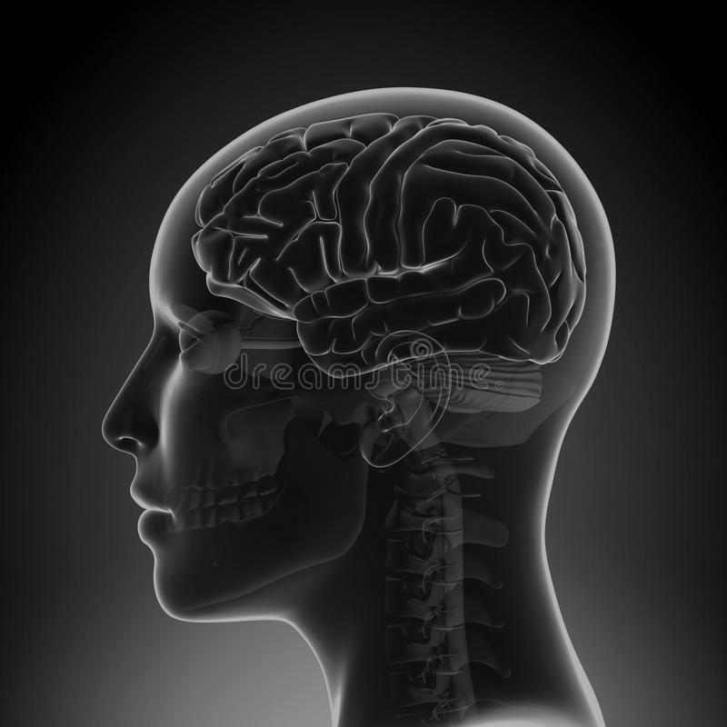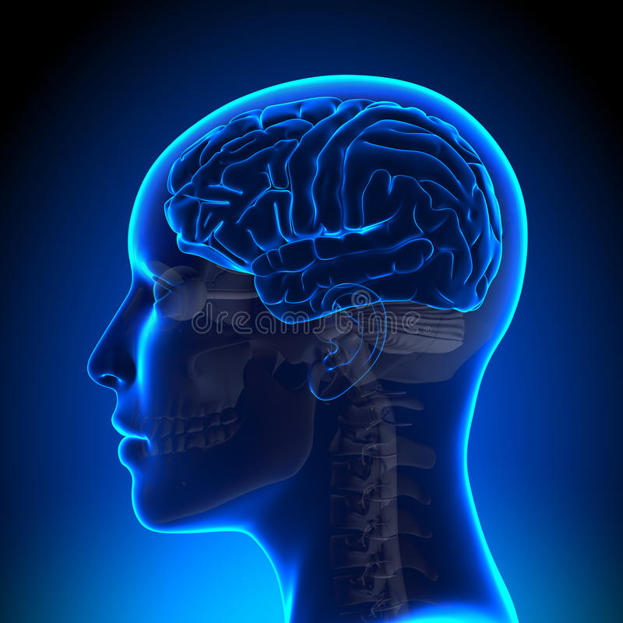Here we use magnitude, angle, real and imaginary to show each Fourier component in Matplot show.

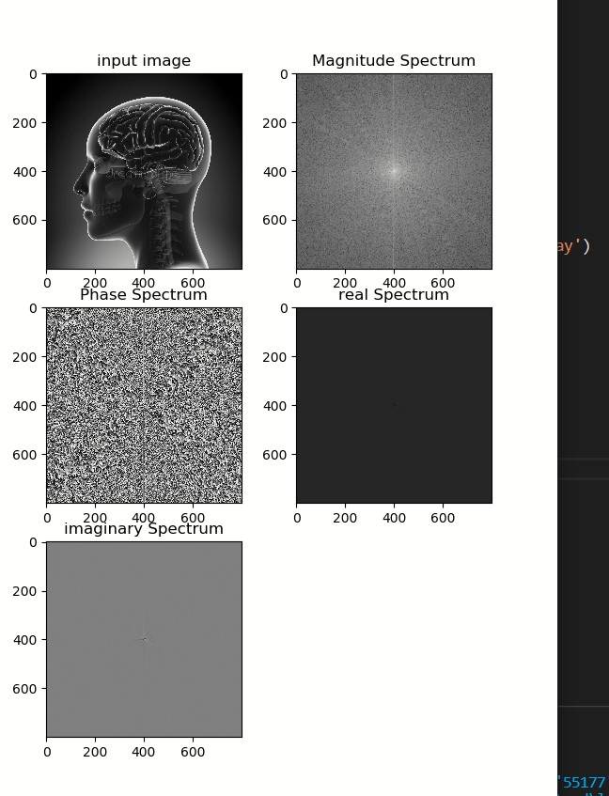

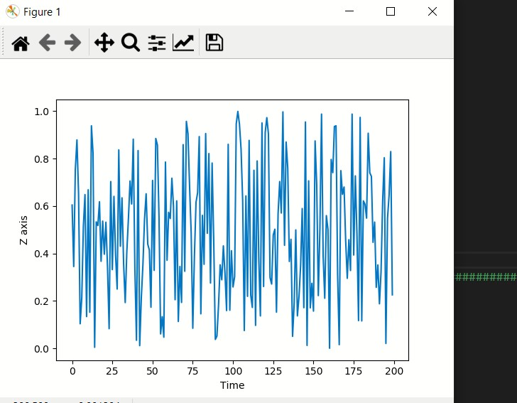

## Python Code:

import numpy as np

from cv2 import cv2 as cv

import matplotlib.pyplot as p

from numpy import random

def main ():

    img=cv.imread('1.jpg',0)

    spectrum =np.fft.fftshift(np.fft.fft2(img))

    p.subplot(321)

    p.imshow(img, cmap='gray')

    p.title('input image')

    p.subplot(322)

    p.imshow( np.log(np.abs(spectrum)) , cmap='gray')

    p.title('Magnitude Spectrum')

    p.subplot(323)

    p.imshow(np.angle(spectrum),cmap='gray')

    p.title('Phase Spectrum')

    p.subplot(324)

    p.imshow(np.real(spectrum),cmap='gray')

    p.title('real Spectrum')

    p.subplot(325)

    p.imshow(  np.imag(spectrum),cmap='gray')

    p.title('imaginary Spectrum')

    p.show()

    z = random.random(200)

    p.ylabel("Z axis")

    p.xlabel("Time")

    p.plot(z)

    p.show()

if __name__=="__main__":

    main()

The code, GIFs and files all uploaded on GitHub:

<https://github.com/Abdolla25/MRI-Task_1>